Service Times Include:
Sunday Morning ~ 9:30am and 11:15am
Full Corporate Worship, N2Y Children’s Ministry
Sunday Evening ~ 6:00pm to 8:00pm
The Uprising Youth Ministry
Small Groups ~ Sunday evenings at 6:00pm


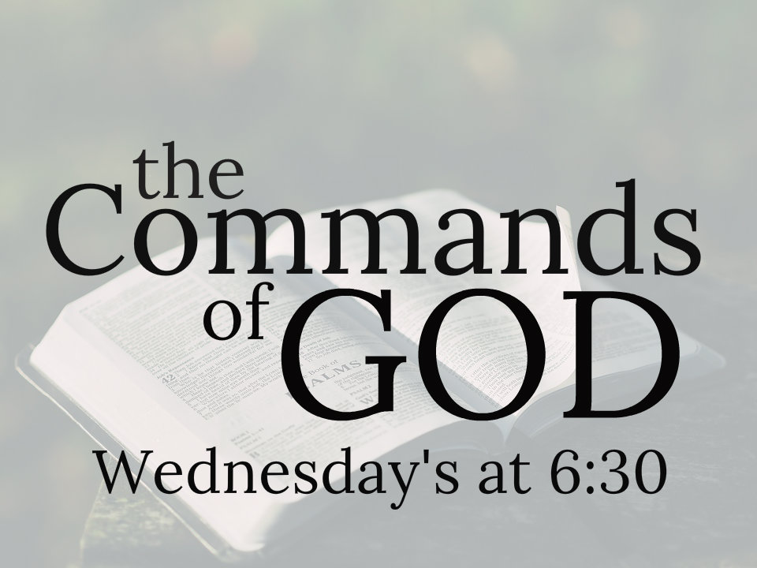
Wednesday Evening~
6:30pm ~ The Uprising Youth Ministry
6:30pm ~ N2Y Children’s Ministry
6:30pm ~ The Commands of God. Adult Bible Study will join in this.

Financial and Attendance Information:
Your 2019-20 Church Board: Sharon Harris, Brenda Pertuset, Scott May, Rod Hetsler, Jean Watters, Inez Bloomfield, Luke Emnett, Blake Howard, Craig Gullion
Cindy McQuay, Ray Elliott
Weekly Budget: $10,100.00
Last week’s offering: $14,699.00
DEBT FREE by 2020 $57,702.00
GOAL: $450,000.00
Alabaster Offering $1,466.91

Worship Attendance: 475
Small Groups: 143

Connect Card / Visitor and Contact Information / Prayer Request
We’re glad you joined us today! If this is your first time with us or if you want to receive more information about the church, or if you have a prayer request, please fill out this card and place it
in the offering plate or hand it to one of our volunteer’s as you leave. Check all the boxes that apply.
This is my first visit  I would like more information about the church   Right Now Media  
     Please add this person to the Prayer List  I would like to be Baptized
      I would like to become a member  I would like to join a Small Group
                

Prayer List is available at CORNERSTONE CONNECTIONS

_________________________________/__________________________________________________
Your Name Phone Number ~ or ~ Person to be placed on Prayer List
*Or Email for Right Now Media

To place a Prayer Chain Call, please call the Church Office at 740-574-2012. Thank you.

March 17, 2019
P.O. Box 538
Wheelersburg, OH 45694

WELCOME

March 17, 2019
9:30am & 11:15am
Rev. Matthew Hancock

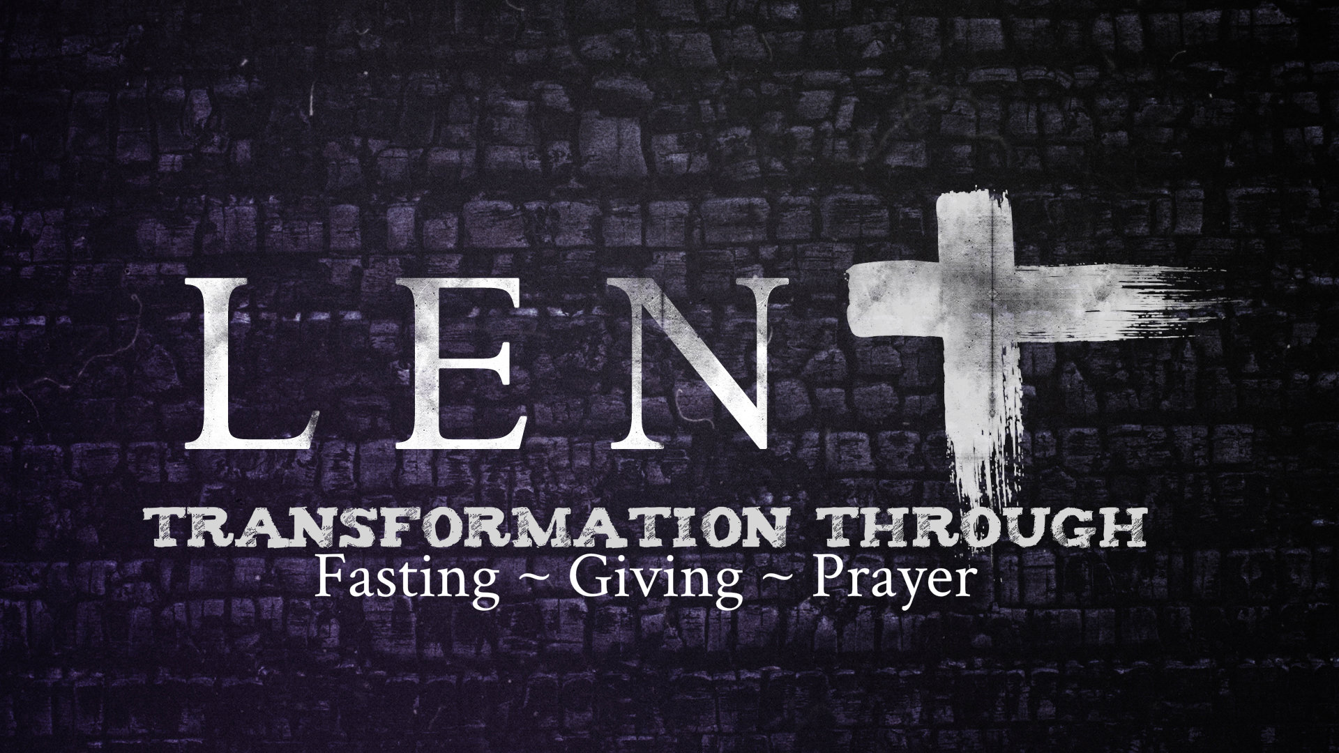

Med Response: Sharli Dempdey & Cindy McQuay
9:30 Service: Chrissy Romanello, Tab & Chris Thoroughman, Aaron Rawlins, JD Emnett, Morgan Howard

SMALL GROUPS ~ If you have never been in a Small Group, this is the perfect time to jump in! Fill out a Connect Card TODAY and get it to a Pastor and we will help you find your people!
#ironsharpensiron
#doinglifetogether

For more detailed information on these ministries and all events coming up at Cornerstone, please visit Cornerstone Connections in the Main Hall
Hallway

Youth
CHILDREN’S MINISTRY ~ N2Y
Praise, Worship, And Bible Lessons
Sundays at 9:30am & 11:15am, and 6:00pm
Wednesdays at 6:30pm

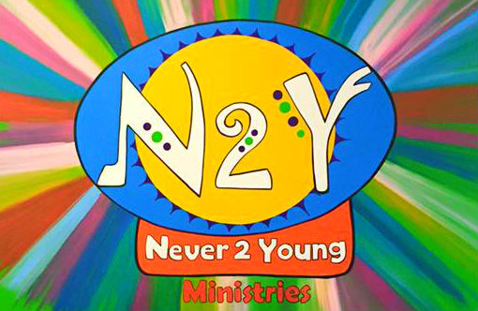

All Church Lucasville Meeting 6:30 Mar 27
JOY Fellowship 6pm Mar 28
True Purpose Girls Conference Mar 29
Small Groups 6pm Mar 31
Adult Bible Study 6:30pm Apr 3
TEEN Spring Vendor Fair Apr 6
Small Groups 6pm Apr 7

DaMAC CONCERT ~ TONIGHT, following the evening Youth at 7:45! All are invited to this ALWAYS FUN TIME!!
Lunch & Dinner is provided
MISSION DAY ~ Hey Kids! Get ready for a full day of exploring!! And meet our Missionaries, Patras and Naomi Rahmat! And then at 6pm you can join your parents as Patras and Naomi bring their amazing testimony to our evening service at 6pm! It’s always a great day in the life of Cornerstone!
LUCASVILLE ~ All church Lucasville meeting March 27th at 6:30pm right here at Cornerstone. Hear all the latest info and see how God is working!
CALENDAR:
Small Groups 6pm Mar 17
DaMac Concert 7:45pm
Adult Bible Study 6:30pm Mar 20
Women’s Bible Study 6:30pm
Missions Day/ Mission Explosion Mar 24
Small Groups 6pm

SHUTTLE SERVICE ~ We are asking as many of our 2nd service people as possible to park at the Porter Township Pool. Our Shuttle service is in full swing after a soft launch a few weeks ago!
If you are able, please drop your family off at the doors and park down at the pool. Then the shuttle will bring you up. They will shuttle you back down after service!
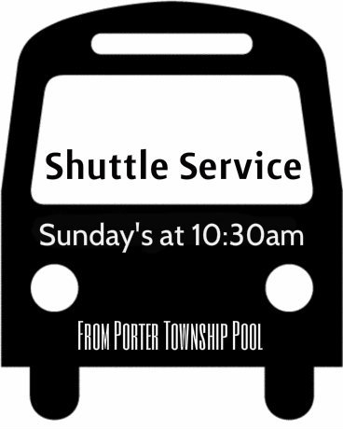
Don’t Forget
facebook.com/Cornerstone-Nazarene
cornerstone.naz.office@gmail.com
740-574-2012

cornerstonenazarene.com
TEEN’S ~ The Uprising
Sunday Night at 6pm in “The Crossing”
Jr High in 2 East
All Teens, Wednesday Night at 6:30pm in
“The Crossing”

