Service Times Include:
Sunday Morning ~ 9:30am and 11:00am
Full Corporate Worship, N2Y Children’s Ministry
Sunday Evening ~ 6:00pm to 8:00pm
The Uprising Youth Ministry
Small Groups~ Small Groups will be back in session the end of Summer
Visit Cornerstone Connections for more details!



Wednesday Evening~
6:30pm ~ The Uprising Youth Ministry
6:30pm ~ N2Y Children’s Ministry
6:30pm ~ Adult Bible Study

Financial and Attendance Information:
Your 2018-19 Church Board: Sharon Harris, Dave Rucker, Brenda Pertuset, Scott May, Erik Bussa, Rod Hetsler, Jean Watters, Inez Bloomfield, Luke Emnett, Blake Howard, Cindy McQuay
Weekly Budget: $9,400.00
Last week’s offering: $10,455.00
DEBT FREE by 2020 $22,097.00
GOAL: $450,000.00
Worship Attendance: 351

Connect Card / Visitor and Contact Information / Prayer Request
We’re glad you joined us today! If this is your first time with us or if you want to receive more information about the church, or if you have a prayer request, please fill out this card and place it
in the offering plate or hand it to one of our volunteer’s as you leave. Check all the boxes that apply.
This is my first visit  I would like more information about the church  
Please add this person to the Prayer List  I am interested in a 2018 Mission Trip
I would like to join a Small Group  Softball Signup  I would like to become a member
❑ I would like to be Baptized  Serve Day ‘18
Prayer List is available at CORNERSTONE CONNECTIONS

_________________________________/__________________________________________________
Your Name Phone Number ~ or ~ Person to be placed on Prayer List

To place a Prayer Chain Call, please call the Church Office at 740-574-2012. Thank you.

June 24, 2018
P.O. Box 538
Wheelersburg, OH 45694

WELCOME
June 24, 2018
Sunday 9:30am & 11:00am

Message By
Pastor Jason Tackett

“A Holiness Church relative to today’s people with a consuming passion to preach Christ, to see lives changed, and to put into balance a healthy perspective of living a joyous life in Christ.”

SERVE DAY ‘18 ~ SAVE THE DATE!!
A day where we serve the community!
FILL OUT A CONNECT CARD TODAY!!
Go online at cornerstonenazarene.com
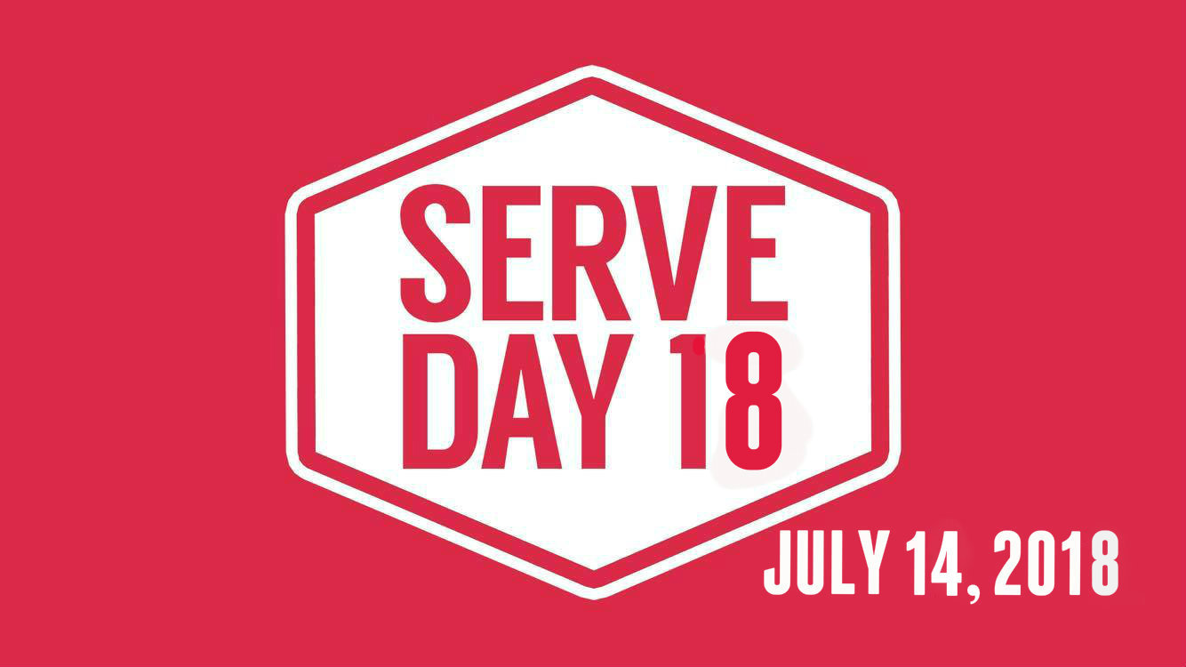

Med Response Team: Luke Emnett & Tine McGraw
9:30 Service: Chrissy & Wes Romanello, JD Emnett, Shelby Gilliland, Charon Hiles

For more detailed information on these ministries and all events coming up at Cornerstone, please visit Cornerstone Connections in the Main Hall
Hallway

Youth
CHILDREN’S MINISTRY ~ N2Y
Praise, Worship, And Bible Lessons
Sundays at 9:30am & 11:00am, and 6:00pm
Wednesdays at 6:30pm

MEN’S SOFTBALL ~ Are you interested in joining the league? Sign up TODAY at Cornerstone Connections. Or fill out a Connect Card.
DEBT FREE BY 2020 ~ Every amount makes a difference! Fill out your commitment card TODAY! We’re moving forward to becoming good stewards together! If you are paying toward Debt Free but have not filled out a Commitment Card, please help us out with our record keeping and let us know! Thanks so much!
DESTINATION UNKNOWN ~ If you have a teen in Uprising, they will NOT want to miss out! Each Wed night in July Pastor Ryan will be taking them to secret locations for some great fun, fellowship, and study! Stay connected for departure times! The first one is July 4th, leaving the church at 5pm!
Don’t Forget!
Adult Bible Study 6:30pm July 18
TEENS Destination Unknown
NIGHT OF WORSHIP July 22
Adult Bible Study 6:30pm July 25
TEENS Destination Unknown
Cactus Mission Trip July 28-Aug 4
Adult Bible Study Aug 1

DIRECTORY UPDATE ~ If you have not yet updated your information and scheduled your family photo for the new directory, please pick up a form at Cornerstone Connections! Photo’s will be taken July 1 & August 5!
KIDS CAMP ~ Kids finishing 1st grade thru 5th grade are invited to this fun time together at Camp Oyo, July 26-28! Only $25 per child! Get registered early at cornerstonenazarene.com *go to the N2Y page. Deadline for registration is June 30th.
CALENDAR:
Adult Bible Study 6:30pm June 27
TEENS Destination Unknown 5pm July 4
No other evening activities at the church
Baby Shower for Julie Scott at 2pm July 8
Adult Bible Study 6:30pm July 11
TEENS Destination Unknown

facebook.com/Cornerstone-Nazarene
cornerstone.naz.office@gmail.com
740-574-2012

cornerstonenazarene.com
TEEN’S ~ The Uprising
Sunday Night at 6pm in “The Crossing”
Jr High in 2 East
All Teens, Wednesday Night at 6:30pm in
“The Crossing”

